Website User Manual

# Instruction

The nursing scheduler is a website that was developed to assist staff to collect related information of both students and instructors, coordinating students’ internship and instructors’ available courses, placing students into appropriate clinical placements with instructors, and recording students’ attendance.

By limitation, the students are only all currently studying at the University of Windsor or ST. Clair college.

This is the home page of the website of the nursing scheduler.

Contents

Instruction 1

Admin Staff 2

Student Portal 6

School Portal 11

Term Management 15

# Home Page

In the home page you can see some summery information in it. Thus, you can easily know the basic information in this website.

There is a summary board for the sum number of each user or place. In this way, you can statistic the number quickly.

In the right of website, you can see the “Recent Activities” as first. This board uses for remind you some recent changes on the website.

Below this board, there is a board for notifications, if you want to add some notices, you can add it in this board.

At the bottom of the website, there are “To Do List” and “Add a note”.

You can see the list that you need to do, and you can also add a new to do thing.

# Admin Staff

The portal allows you to add a new admin staff, modify any staff’s status, view the staff’s information, and update the staff’s all information and edit the comment.

Select “Admin Staff” button.

1. View admin staff information list:

As you can see each staff’s information with unique admin number, first name, last name, university ID, status of account and comment.

In this page, you can add or remove the comment. If you want to write some comment, you can click “Add” and write in it. “Remove” means delete this comment.

For the status of staffs’ accounts, there are two statuses, “ACTIVE” and “INACTIVE”.

Active means, this staff can log in his or her account. If account status is inactive, this person cannot log in anymore.

AS you click “” button, the status will be “ACTIVE”.

When you click “ ” button, the status will be “INACTIVE”.

Otherwise, when you add a new admin staff, the status of this new account is “ACTIVE”.



1. Order the information

There are two order methods on the website, descending sort, and ascending sort. When you open this page, the default is in ascending order by admin number. If you click the order button, the order will be descended. The order function works on any line with symbol “”. Here is the example of descending order by first name.

1. Add a new user to Portal

Select “Add a new user to Portal”, then,

Then, fill each textbox. The “*” means you must fill this information.

After you enter all required information, click “Submit” button, and the new staff information is added. Then, click “Back”, you can see the new staff information is in the list.

# Student Portal

The portal allows you to add a new student, modify any student's status, view the student's information, and update the student's all information and change the student's placement.

Meanwhile, you can assign the class and section for each student.

Select “Student Portal” button.

In this page, you can also add or remove the comment. If you want to write some comment, you can click “Add” and write in it. “Remove” means delete this comment.

When you add a new student, the default status of this student is active.

1. View student information list:

In this page, there are some important information of each student, such as student number, name, UwinID, address, contact information, start term, status, and comments.

If you want to see the detail information of a student, you can click “”, and the page will show the details.



If you want to see the detail information of Jake, you can see this page.

1. Add a new student

In this page, you need to fill required information, and select status and start term.

Then, click “Back” to return to the homepage of student portal.

1. Assign the new section or class to students

If you want to assign new section or class to a student, you can click “”.

In the next step, you need to select a class and a section for this student. Here are the selections of classes and sections. After selection, click “Enroll” to finish the assign.

1. Edit student information

If some information of student needs to be modified, you can click “”.

The page will jump to “Student Update Details” page, then make the changes on the original information. In addition, the “*” means you must fill this information. Thus, you must fill these textboxes after you make changes. Then, click “ 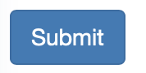” to finish the modify, the pages will return the student information list page, and you can see the update information.

# School Portal

The portal allows you to add a new school, modify any school's status, view the school's information, and update the school's all information.

Select “School Portal” button.

1. View school information list:

In this page, you can see school name and school abbreviation of each school. Then, you can add a new school, limit a school, and edit a school information.

If you want to see the detail information of a student, you can click “”, and the page will show the details.

1. Add a new school

” button, then fill the textboxes.

After that, submit it and you can see a new school information in the school portal page.

1. Edit a school information

If you want to edit a school information, click the green pencil button.



Then, you can see the original information of this school. You can make some changes on it and submit it to finish the modify.

# Term Management

The portal allows you to add a new term, modify any term's status, view the term's information, and update the term's all information.

Select “Term Management” button.

The function is similar as the school, which includes changing status, adding a new term, browsing the details, and editing information.

1. View term list:

1. Add a new term

You should input the term ID and term name in it to insert a new term, so you can assign this new term to students.

1. Edit a term

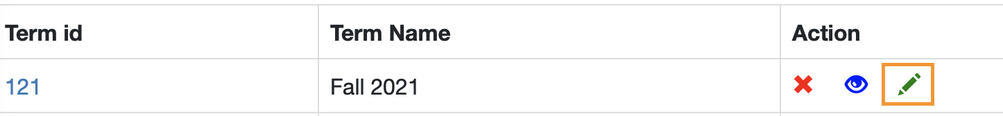

# Instructor Portal

The portal allows you to add a new term, modify any term's status, view the term's information, and update the term's all information.

Select “Instructor Portal” button.

1. View instructor list:

1. Add a new instructor: firstly, you should click the “Add a new instructor” button then you will see the detail of inserting a new instructor as the second picture shown.

1. Edit the information of one instructor: for example, this page, you can add or remove the comment. If you want to write some comment for this instructor, Abigail Gill, you can click “Add” and write in it. “Remove” means delete this comment.

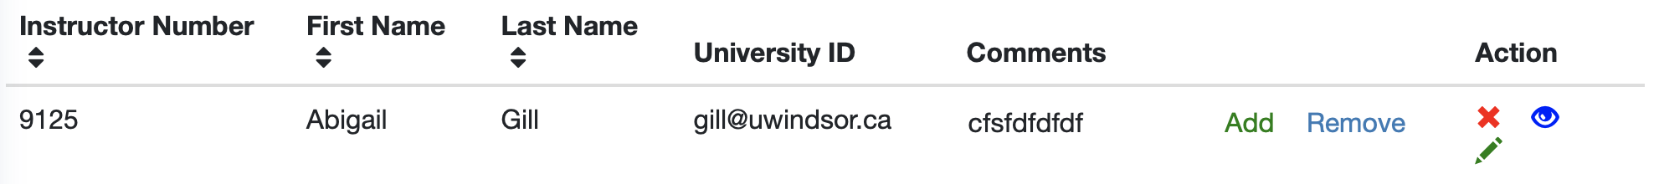

To update the status of instructors’ accounts, there are two statuses, “ACTIVE” and “INACTIVE”.

Active means, this staff can log in his or her account. If account status is inactive, this person cannot log in anymore. When you click “ ” button, the status will be “INACTIVE”. By default, a new admin user will have an ACTIVE status.



To view the details of instructors’ accounts, you can click “” button to see all information of this instructor.



To update the details of instructors’ accounts, you can click “” button to see all information of this instructor.



# Placement Records

The portal allows you to add or/and edit a new hospital, modify any student's status pertaining to placement, view the student's placement information, update the term's all information, and add a comment into the student by admin staffs, for example, the student should update their own information.

Select “Placement Records” button.

1. View the details of students’ placements:

1. Add a new hospital: firstly, you should click the “Add a new Hospital” button then you will see the detail of inserting a new hospital as the second picture shown.

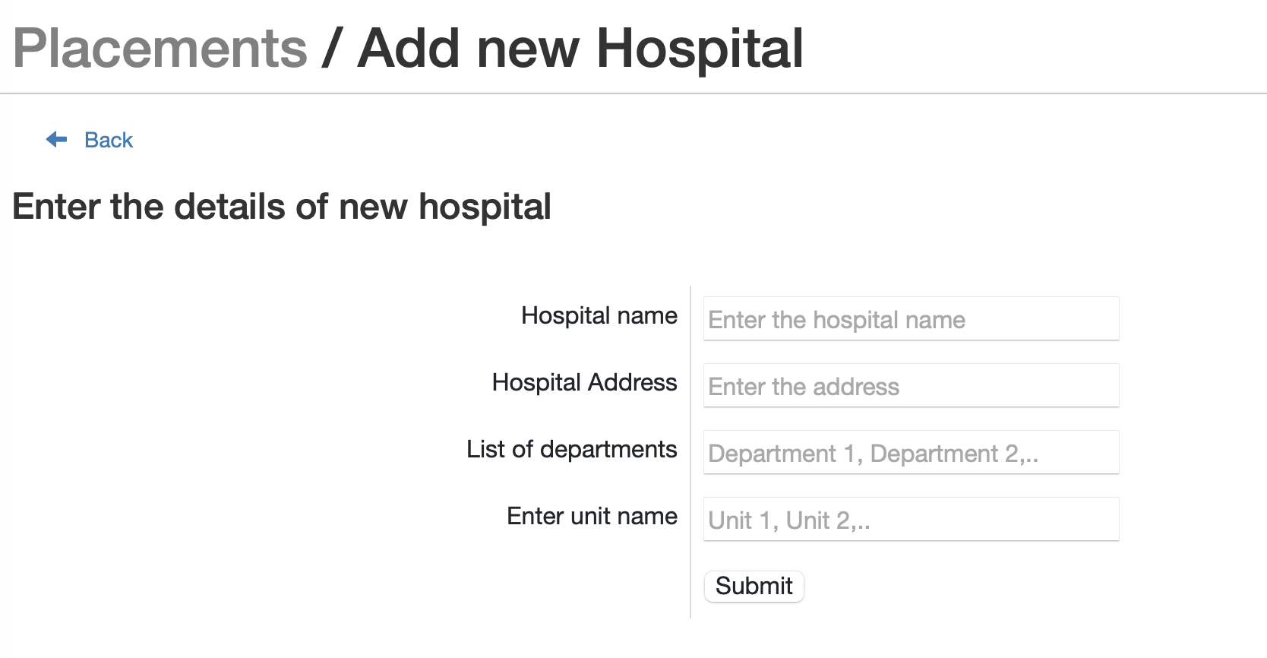

1. Edit the information of one hospital: firstly, you should click the “Edit hospital details” button then you will see the detail of editing a new hospital as the second picture shown, for example, you can remove the departments or units in any hospital.

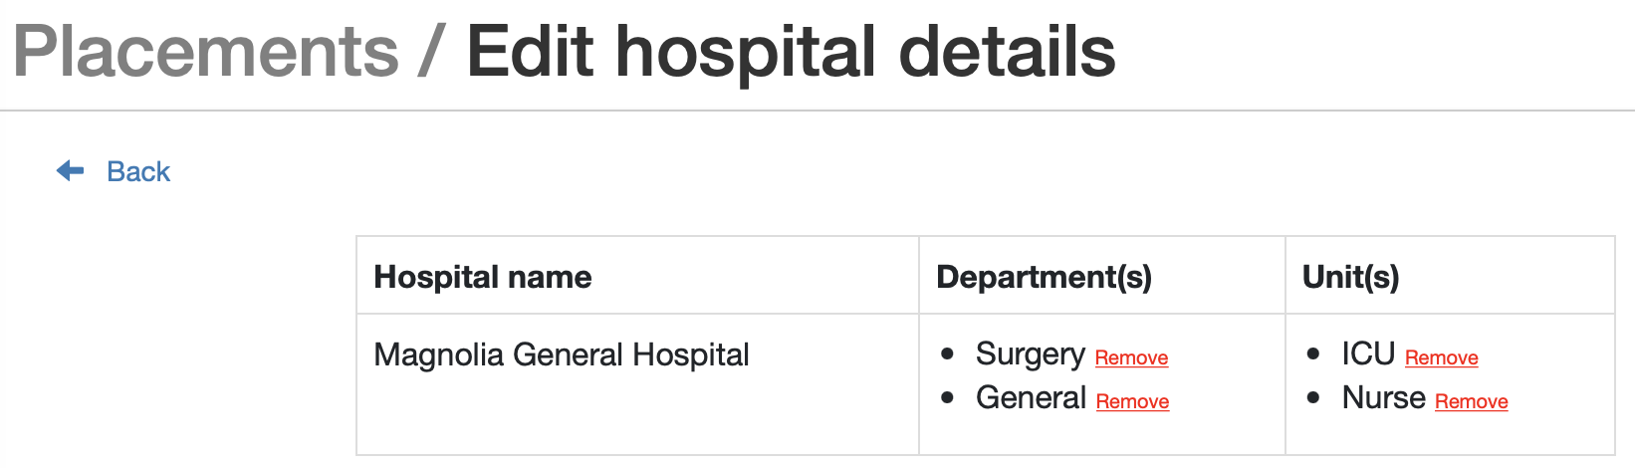

1. Edit the information of one student’s placement: for example, this page, you can add or remove the comment. If you want to write some comment for this instructor, Sam Davies, you can click “Add” and write in it. “Remove” means delete this comment.

To update the placement status of students, there are two statuses, “Placed” and “Not Placed”. The status, “**Placed**”, means that the student is placed into a unit.

Otherwise, the status, “**Not Placed**”, means that the student is not placed into a unit, then staffs are required to put the student into appropriate unit by clicking “” button to see all information of this instructor as the second picture shown. Table

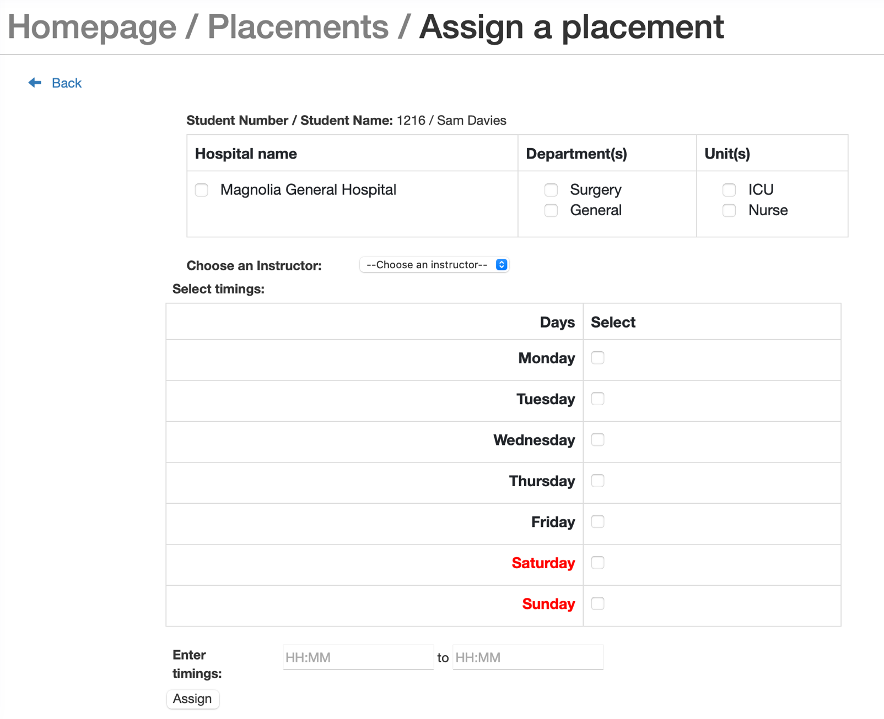

To view the details of students’ placement information, you can click “” button to see all information of the placement.

To report/view absences: firstly, you need to enter to see all information of the placement, then you can click “Report/View absences” to enter the page to review and create one new absence.Graphical user interface, table

To report/view incidents: firstly, you need to enter to see all information of the placement, then you can click “Report/View incidents” to enter the page to review and create one new absence.

# Placement Records

The portal allows you to add a new term, modify any term's status, view the term's information, and update the term's all information.

# Report Generation

The portal allows you to add a new term, modify any term's status, view the term's information, and update the term's all information.

# Help

The portal allows you to add a new term, modify any term's status, view the term's information, and update the term's all information.